Using Javascript Objects:

Need a way to send an Object of Type user to the backend:

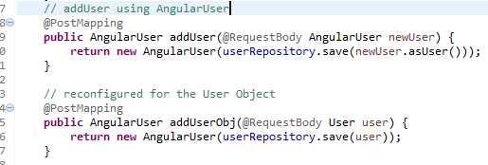

Cannot have both running:

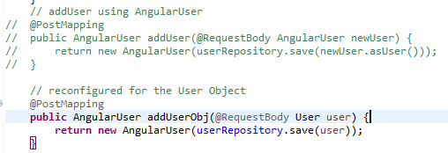

Add addUserObj to user-edit-component class

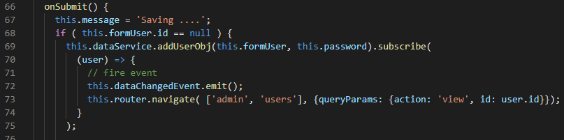

Put in reflective method in user-component.ts class

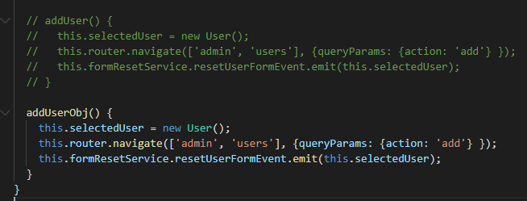

Add reflective method to the dataservice.ts class

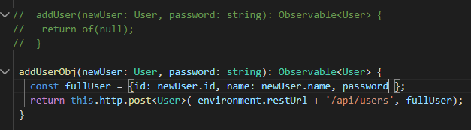

Use the right calling method in the html file:

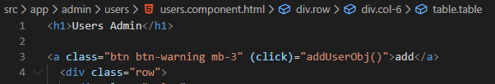

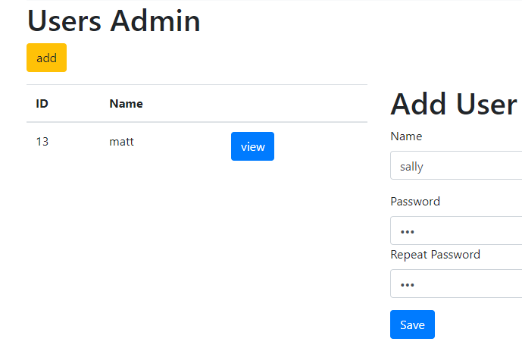

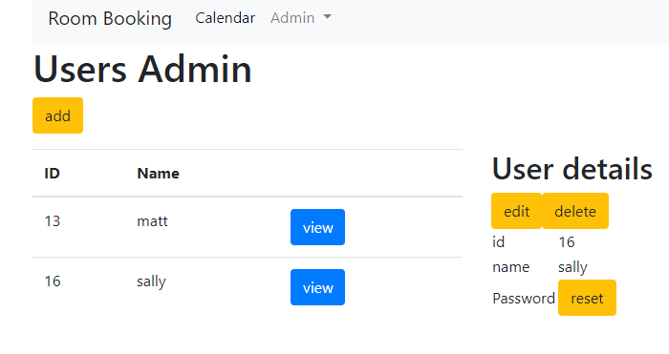

It works!! Should replace the addUserObj() with addUser()

Add the Error condition as an extra parameter in the user-edit-component class

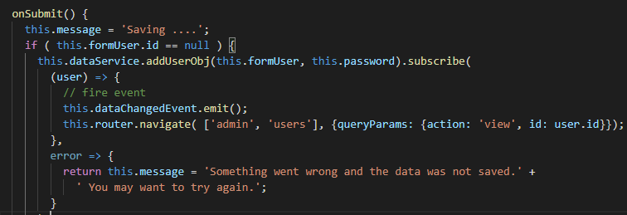

**Exercise 3 – POST and PUT**

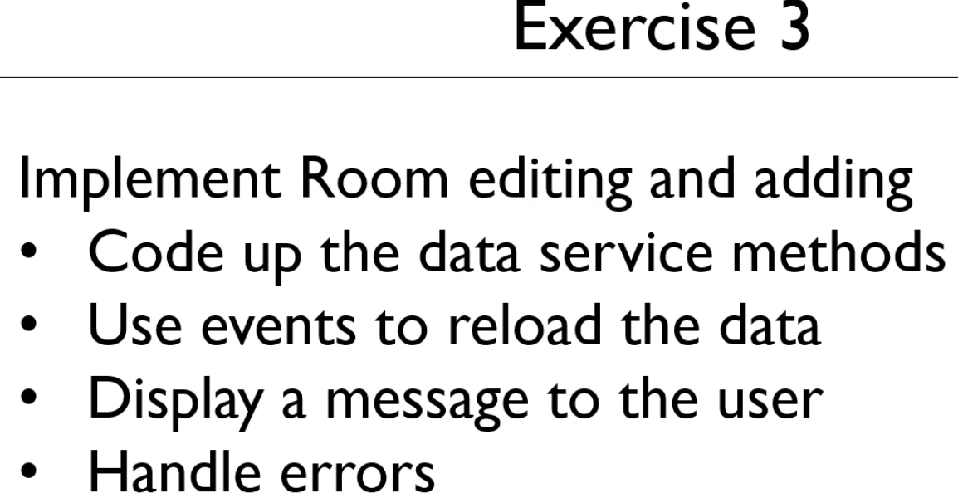

In the dataservice.ts class implement the updateRoom:

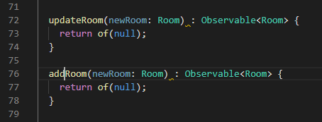

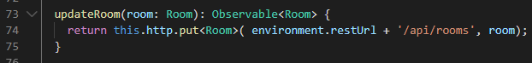

Create an event in the room-edit-component.ts class:

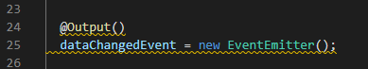

For error handling let us create a message variable

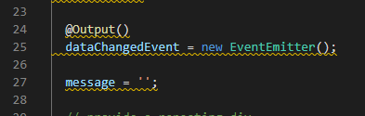

**Let us populate the expected message delay:** Saving …

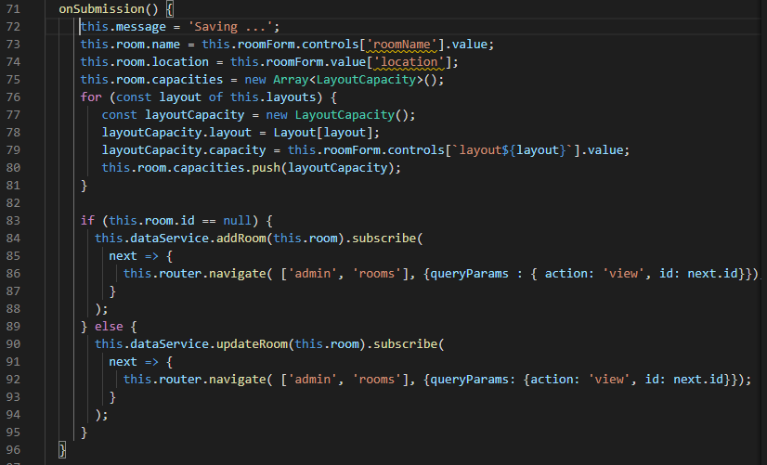

Fire off the event (this.dataChangedEvent.emit) as soon as the Save is complete

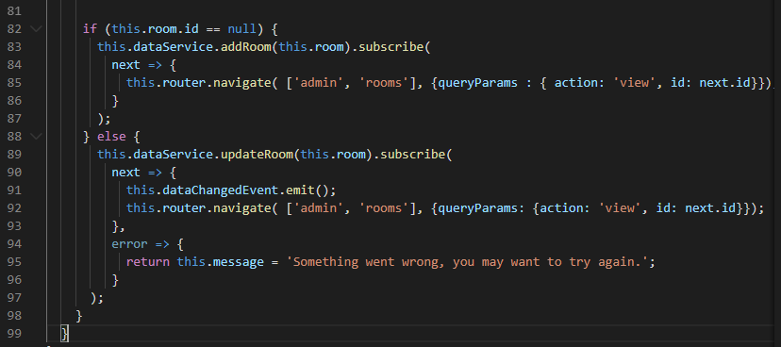

Remember to import the EventEmitter into the @angular/core import

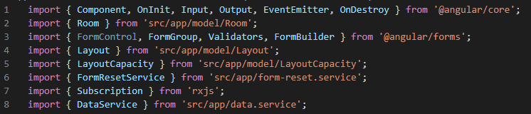

Now in the the room-edit-html page we need to code the handlers:

Added the div for the message

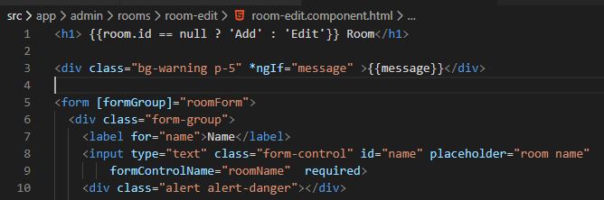

Now go to the rooms.component.ts and bind subscribed to the event

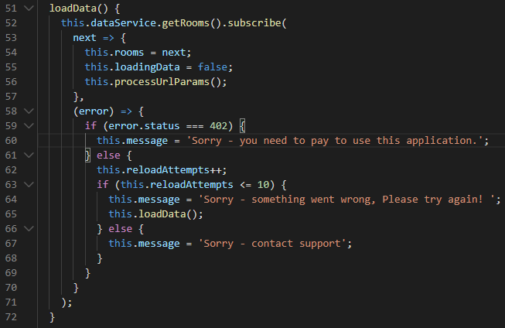

Now, code the html page, rooms.component.html – add the dataChangedEvent

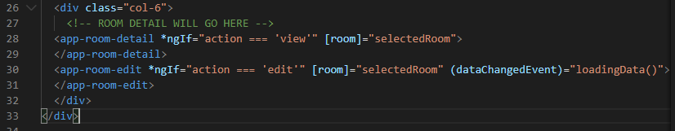

This is not loadingData() but loadData()

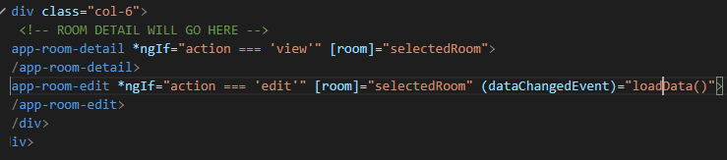

Now, let us test this:

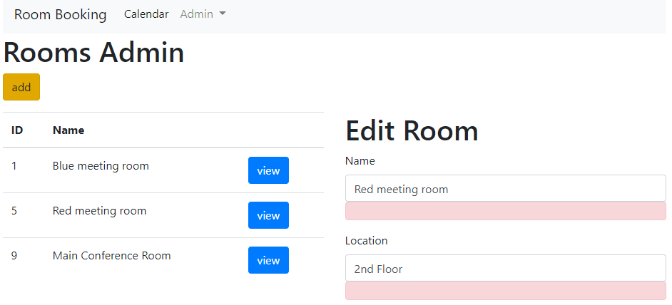

Edit the Location to 2nd Floor East and Save

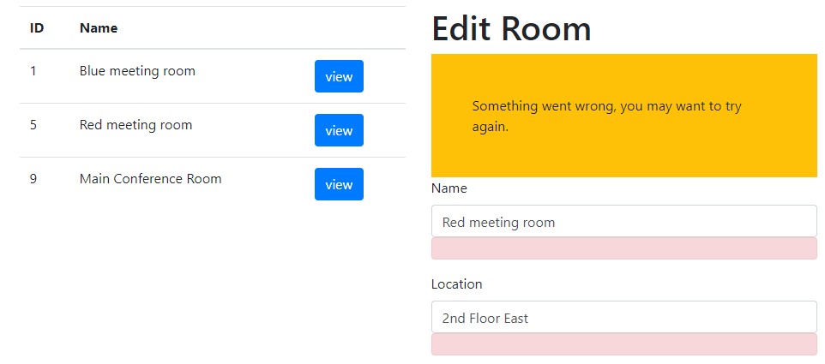

There is an error on the REST server:



We need to convert the layout json into an uppercase value

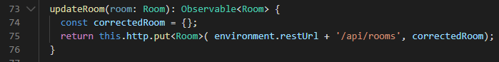

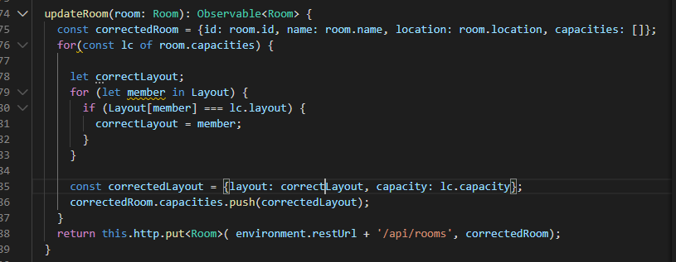

Try it

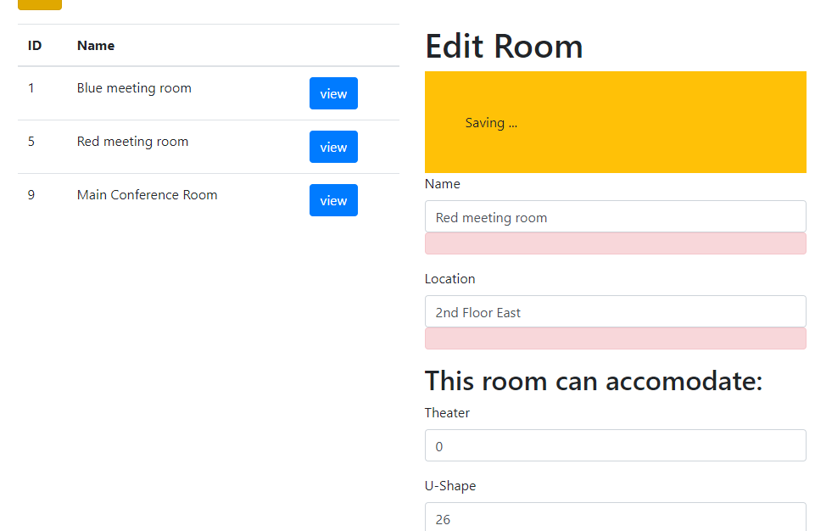

This time it is Saving …

Refreshing the page show that the change to East has worked.

Use this.room.id and replace next with room fixes the id failing on null error: Now refresh is no longer

necessary to see the data update!

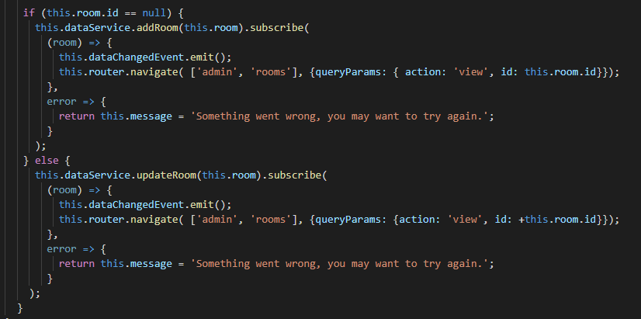

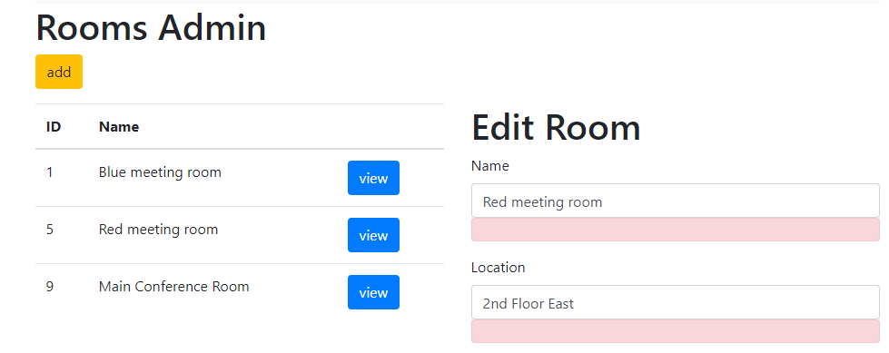

Extract the Correction:

Create method getCorrectedRoom(room)

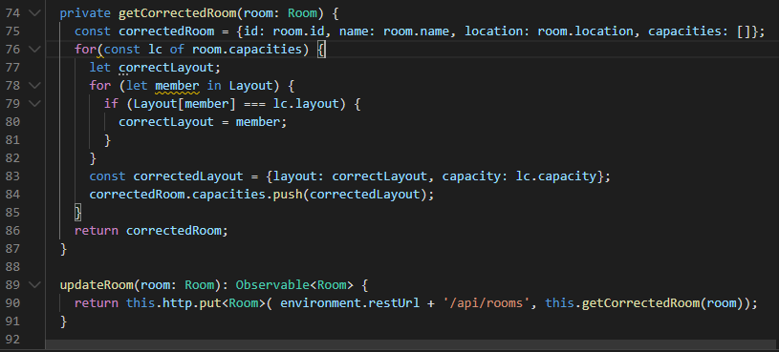

Now code the addRoom(room)

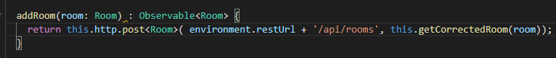

Refresh on Saving … does not work yet!!

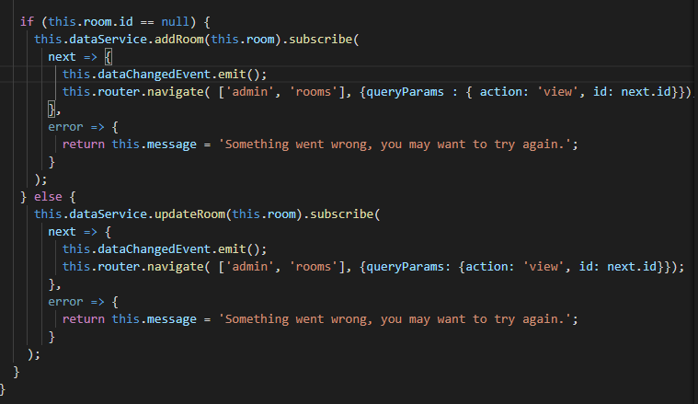

Try it, Add room

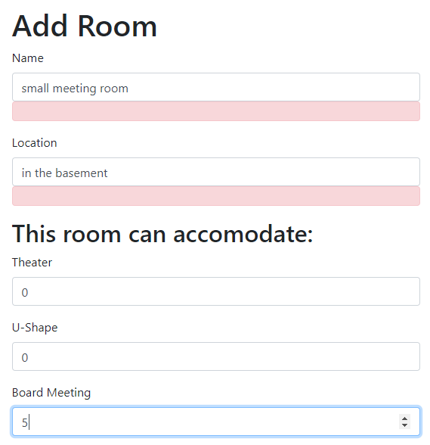

It works

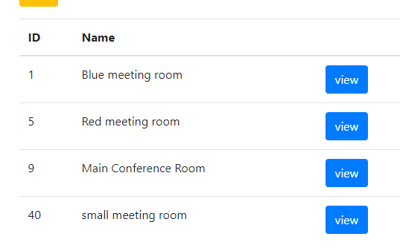

**Bug Fixing:**

Prevent time delay capacity error: We do this by removing the display until the data is ready.

Go to Room-Detail-component.html page

Add *ngIf=”room.capacities”

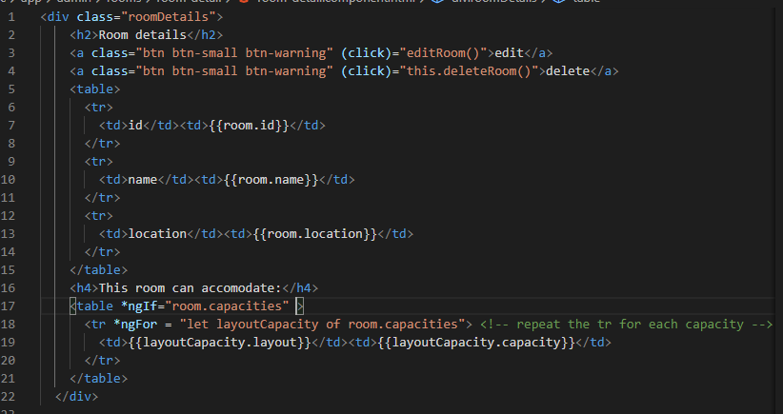

Add a null check!

Only get the id if the id is not null

{{room?.id}} null safety check ?

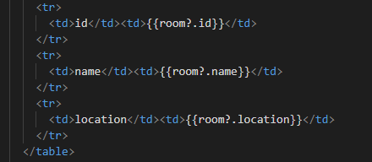

Test for the capacities error

BiggestRoom added with no capacity error

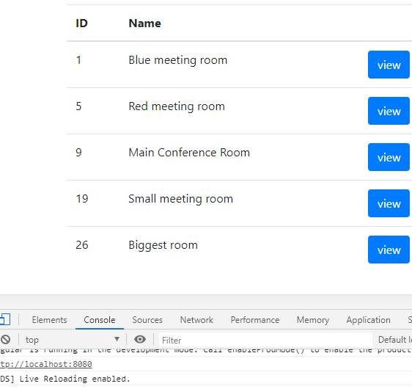

Do the same in the User-Detail.component.html

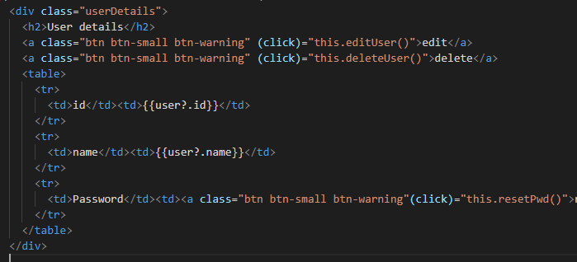

The ? null safety check added twice. user?.id and user?.name

Done!!